Measuring Cellular Respiration and Fermentation

Student’s Name
Institutional Affiliation
Course Name and Number
Instructor’s Name
Submission Date

Introduction
Cellular respiration refers to a chemical reaction that occurs in living organisms’ cells to produce energy. Cellular respiration occurs when an organism exercises its muscles to supply the body cells with enough ATP energy for enhancing their functioning. During cellular respiration, the organism requires oxygen for oxidation of food, which is broken down, releasing carbon (IV) oxide. Fermentation refers to the metabolic process, which is used to produce chemical changes in organic substrates through enzymes' action (Babcock, 2012). For respiration to occur, three necessary parties must be involved: the organism, the substrate to be used in the respiration process, and oxygen, which is the oxidizer of the food substrate to produce energy. The amount of oxygen used or the amount of carbon (IV) oxide released after the respiration process helps determine the extent to which the rate of respiration has occurred. Therefore, experiments can be carried out to measure the rate of respiration and fermentation.
Experiment 1
Cellular respiration in Beans
Materials and requirements
Wet/soaked germinating and dry beans seeds of the same size, two clean test tubes with stoppers, two graduated pipettes, a colored liquid, stopwatch, water bath at room temperature, labels, and potassium hydroxide pellets, and cotton wool.

Procedure
Label the two test tubes tube one and tube two, respectively. In each of the two clean test tube's stoppers, a pipette was inserted. Each test tube was served with some potassium hydroxide pellets. A ball of cotton wool was then forced into each test tube with KOH (Bryan,2010). Three wet/soaked germinating bean seeds were placed in tube 1. In tube two, three dry bean seeds were paced. Each of the tubes was then corked with a cork fitted with a pipette filled with the colored liquid to around 0.5mm. The experiment was then left for twenty minutes, and observations in the colored liquid movement in each pipette were observed. The set up was as shown below.

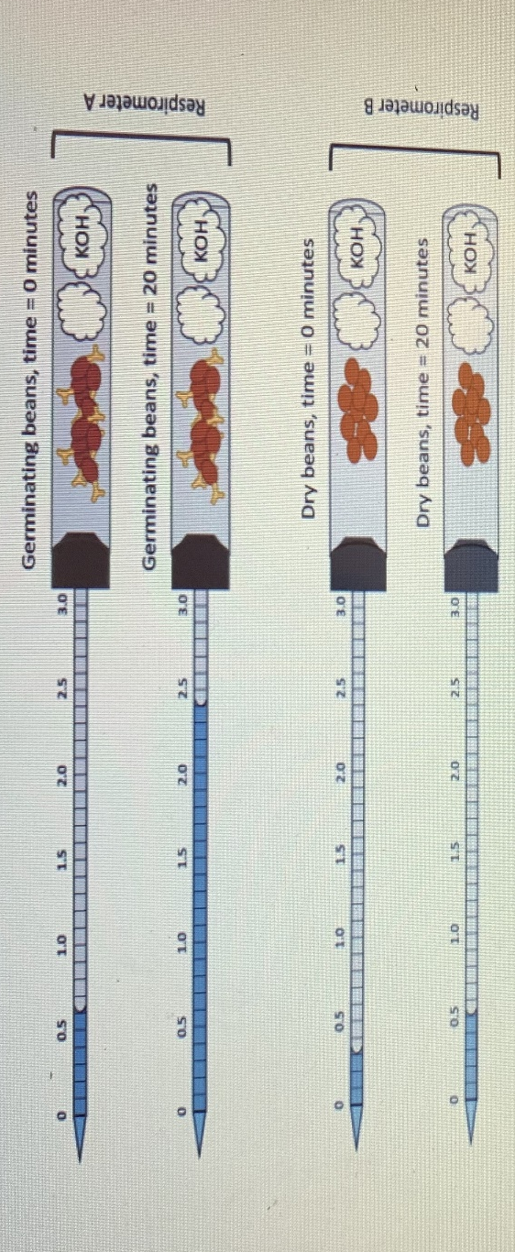

Experiment 2
Yeast Fermentation
Materials and requirements
Four clean boiling tubes, Glucose, sucrose, labels, stopwatch, fructose, water, four clean test tubes, stopwatch, and yeast.
Procedure
Label the four test tubes as Glucose, sucrose, fructose, and water. In each test tube, add the respective solution about a quarter full (Bryan,2010). Add a spatula full of yeast and invert the test tube and its contents into a boiling tube. Allow the experiment to take place for about twenty minutes. The set up will appear as in the figure below.
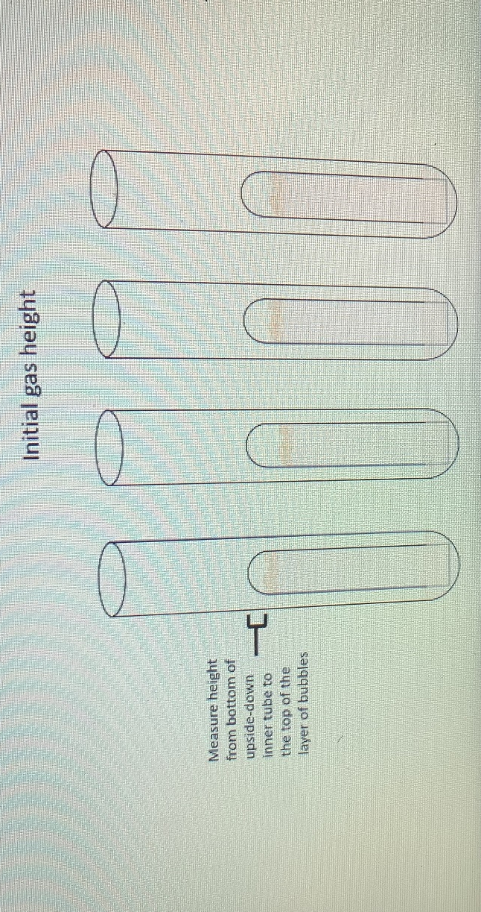

Results and discussion
Experiment 1
Cellular respiration in Beans
Respirometer | Contents | Oxygen consumption after 20 minutes | Oxygen consumption after one hour
A | Germinating bean seeds | 2.0 | 6.0
B | Dry bean seeds | 0.5 | 0.5

To account for the oxygen consumption after one hour in respirometer A, the amount consumed after twenty minutes was multiplied by three since an hour has sixty minutes, which is three times more than twenty. While in respirometer B, the amount of oxygen consumption remained the same in both after twenty minutes and after one hour.
In the tube that contained germinating seeds, the colored liquid moved from the 0.5mm mark to the pipette's 2.5mm mark. Such changes occurred since the germinating seeds used the oxygen in the tube during the respiration process as the seeds were growing; thus, a vacuum was created inside the tube. The vacuum then created a sanction force that pulled the colored liquid towards the tube through the calibrated pipette. The carbon (IV) produced as a by-product after respiration was absorbed by the potassium hydroxide placed in the tube; thus, it could not replace the space previously occupied by the oxygen. The cotton wool was used in the tubes to ensure that the beans do not contact the potassium hydroxide, which can kill them.
In the tube which contained dry beans seeds, the colored liquid remained in its original mark point of 0.5mm. Such observations resulted since dry beans lacked moisture, which was vital for germination to take place. Thus there was no respiration; hence no oxygen was used up, creating a sanction force that could have pulled in the colored liquid through the pipette.

Experiment 2
Yeast Fermentation

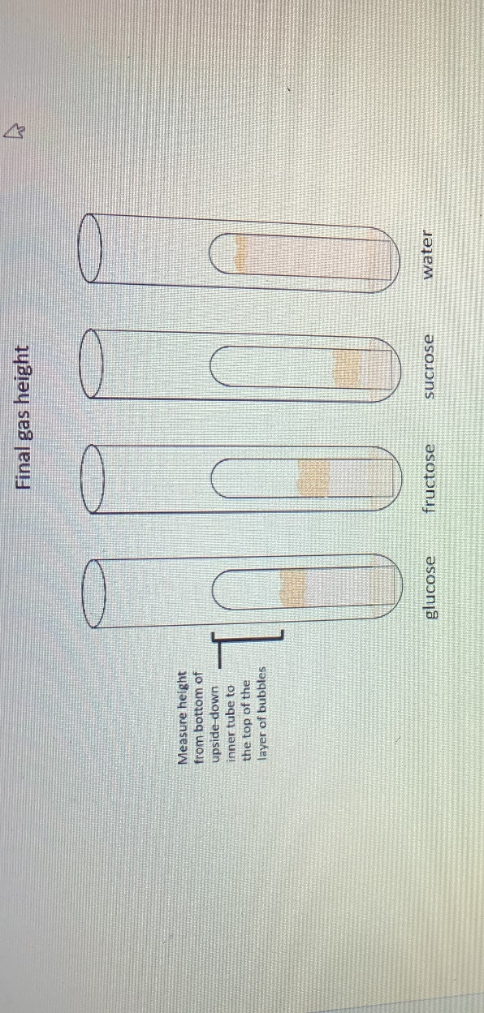

In the comparison of the initial heights and the final heights in each of the tubes with different contents, it was observed that the height rises more in the tube which had Glucose, followed by the tube with sucrose then lastly the tube which had fructose, the tube which contained deionized water there was no change in bubbles height (Van Dijken, 2016). The tube that contained Glucose, a simple monosaccharide, the simple sugar was acted upon rapidly by yeast during respiration producing more bubbles of carbon (IV) oxide gas. In the sucrose and fructose, the two sugars were disaccharides; thus, yeast's action during respiration to release carbon (iv) oxide was minimal. Water had no bubbles of any carbon (iv) oxide, which was released since water has no sugar, which could have been used in respiration by yeast to produce the gas.
Tube | Sugar | Initial gas height (mm) | Final gas height (mm) | Change in gas height (mm)
1 | Glucose | 12.0 | 24.9 | 12.9
2 | Sucrose | 12.0 | 21.3 | 9.3
3 | Fructose | 12.0 | 18.3 | 6.3
4 | Deionized water | 12.0 | 12.0 | 0.0

- What is the dependent variable for the experiment of yeast fermentation?
The dependent variable is sugar.
- What is the dependent variable for the experiment of yeast fermentation?
The independent variable is yeast.
- Which sugar resulted in the fastest production of Carbon (IV) oxide gas. Explain.
The sugar, which resulted in the fastest production of Carbon (IV) oxide, was Glucose (Van Dijken, 2016). Glucose was fastest in gas production since it was a monosaccharide, and monosaccharides are readily fermented by yeast to produce ATP energy and Carbon (IV) oxide gas.

Conclusion
Experiments were carried out to measure the rate of respiration and fermentation. To measure the cell respiration, both germinating and dry bean seeds were used in the experiment. The dry bean seeds were used as a control experiment. In the experiment to test for fermentation, four substances that are Glucose, sucrose, fructose, and water were used. The three sugars gave positive results but at different rates, while water gave no bubbles production results. Water had no sugar, thus gave a negative result. Water was used to demonstrate a control experiment (Van Dijken, 2016). The sugar, which resulted in the fastest production of Carbon (IV) oxide, was Glucose. Glucose was fastest in gas production since it was a monosaccharide, and monosaccharides are readily fermented by yeast to produce ATP energy and Carbon (IV) oxide gas.

References
Babcock, G. T., & Wikström, M. (2012). Oxygen activation and the conservation of energy in cell respiration. Nature, 356(6367), 301-309.
Bryan, W. L. (2010). Solid-state fermentation of sugars in sweet sorghum. Enzyme and Microbial Technology, 12(6), 437-442.
Van Dijken, J. P., & Scheffers, W. A. (2016). Redox balances in the metabolism of sugars by yeasts. FEMS Microbiology Reviews, 1(3-4), 199-224.

